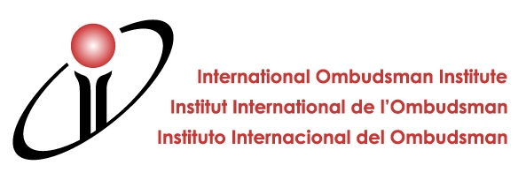

IOI Workshop for NPMs
“Communication skills & techniques”

25 – 27 September 2017Vienna, Austria

REGISTRATION FORM

Please return the completed registration form to the IOI General Secretariat by Email (ioi@volksanw.gv.at) or fax (+43 1 512 93 88 200) as soon as possible but no later than 14 July 2017!

Participant Information
Mr. / Ms. / Title
First Name
Last Name
Institution
Function
Address
Zip Code
City
Country
Phone number
Email

Travel Information
 | Date | Time | Flight Number
Arrival
Departure

Accommodation
Please indicate whether you want the IOI General Secretariat to make reservations for you at Motel One. Please note that payment has to be made by the participant upon arrival / check-in at the Hotel.

If you prefer to make your own room reservations for your stay in Vienna, please leave the following portion of the registration form empty!

Please arrange room reservations for me at Motel One as follows:
Name of guest
Room type | double room, single use (€ 100,74) / double room, double use (€ 125,62)
Arrival date and time
Departure date and time
Credit card details* | card type / card holder / card number / validity

*The Secretariat will forward this information to Motel One to guarantee your reservation; for cancellation terms please see “practical information”

Informal get-together & Dinner
Please indicate whether you would like to participate in the following evening events.

Event | YES | NO
Informal get-together (Sunday, 24 September 2017)
Official dinner (Tuesday, 26 September 2017)

Special requirements
Please indicate whether you will have any specific requirements or will need special assistance.

Dietary requirements (if any)

Other requirements (if any)

